**CS 248**

**Term Project: SuperStore**

<https://community.tableau.com/docs/DOC-10371>

To import superstore DB

Increase the import size

Xampp/php/php.ini

; Maximum allowed size for uploaded files.

; http://php.net/upload-max-filesize

upload_max_filesize=2M becomes upload_max_filesize=50M

; Maximum size of POST data that PHP will accept.

; Its value may be 0 to disable the limit. It is ignored if POST data reading

; is disabled through enable_post_data_reading.

; http://php.net/post-max-size

post_max_size=8M becomes post_max_size=50M

______________________________________

Launch the servers

phpMyAdmin

Create the database

**Home > Databases > Create database (superstore)**

Import this file

**in10-analytics.rds.amazonaws.superstore.sql**

Go

GRANT SELECT, INSERT, DELETE, UPDATE

ON superstore.*

TO mgs_user@localhost IDENTIFIED BY 'pa55word'

**Assignment Requirements**

superstore tables

|  |  |  |
| --- | --- | --- |
| **orders table** | **people table** | **returns table** |
| Row_ID | Person | Order_ID |
| Order_ID | Region | Returned |
| Order_Date |  |  |
| Ship_Date |  |  |
| Ship_Mode |  |  |
| Customer_ID |  |  |
| Customer_Name |  |  |
| Segment |  |  |
| Country |  |  |
| City |  |  |
| State |  |  |
| Postal_Code |  |  |
| Region |  |  |
| Product_ID |  |  |
| Category |  |  |
| Sub_Category |  |  |
| Product_Name |  |  |
| Sales |  |  |
| Quantity |  |  |
| Discount |  |  |
| Profit |  |  |

* You must use MVC architecture
* Categories:
  + All
  + Office Supplies
  + Furniture
  + Technology
* Segments:
  + All
  + Consumer
  + Corporate
  + Home Office
* State
  + All
  + List of States

**Grading Rubric**

**4 Points each**

**Styles**

Layout

Color

**Sticky Dropdown Menus**

Categories

Segments

States

**Display**

Current Date

**Displa**y

Category

Segment

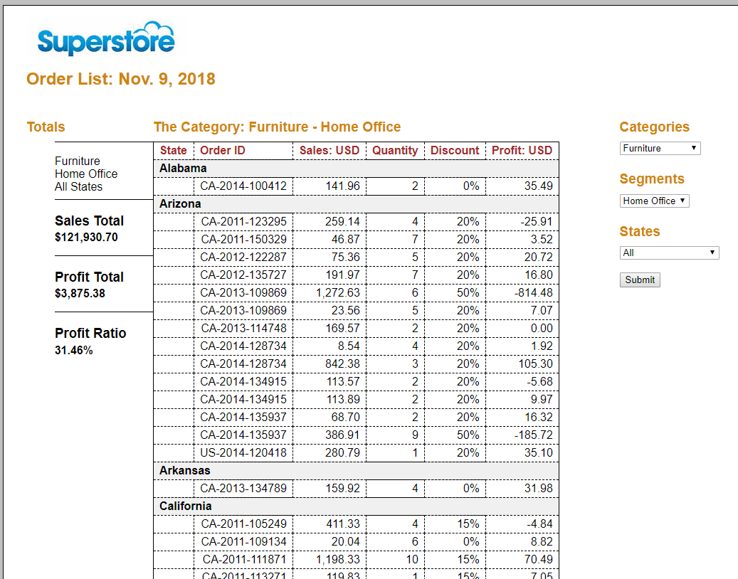

State Divider

**Affected by dropdown options**

Sales Total

Profit Total

Profit Ratio

**Affects table**

Categories

Segments

States

**Populate**

Categories

Segments

States

**Display**

Categories

Segments

States

**Display**

Sales Total

Profit Total

Profit Ratio

**Ordered by**

Order ID